

Faculty of Technology and Engineering
Chandubhai S. Patel Institute of Technology (CSPIT) Department of Computer Science & Engineering
Date:15/08/2026
Laboratory Manual

Academic Year | : | 2026-27 | Semester | : | 3rd
Course code | : | ITUE203 | Course name | : | WEB DEVELOPMENT FRAMEWORKS

Practical – 3:-
Responsive UI Design using CSS Grid, Flexbox, and Bootstrap/Tailwind
Problem Statement:-
Design responsive layouts for Home, About, Registration, Dashboard, and Events pages using CSS Grid and Flexbox. Optional to use CSS framework such as Bootstrap or Tailwind. Ensure mobile-first
responsiveness.
.
Objective:- Create a mobile-first, responsive multipage layout blueprint (Home, About, Registration, Dashboard, Events) using Tailwind CSS (utilizing Flexbox and CSS Grid) to ensure seamless adaptation across mobile, tablet, and desktop screens..

https://github.com/D26CS122/StudentHub
Github Repository link:-
Screenshots:- code -:
Html Grid code and output
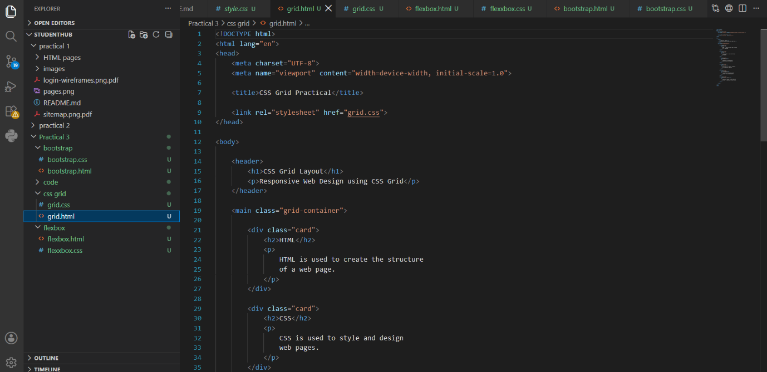CSS style sheet code and output
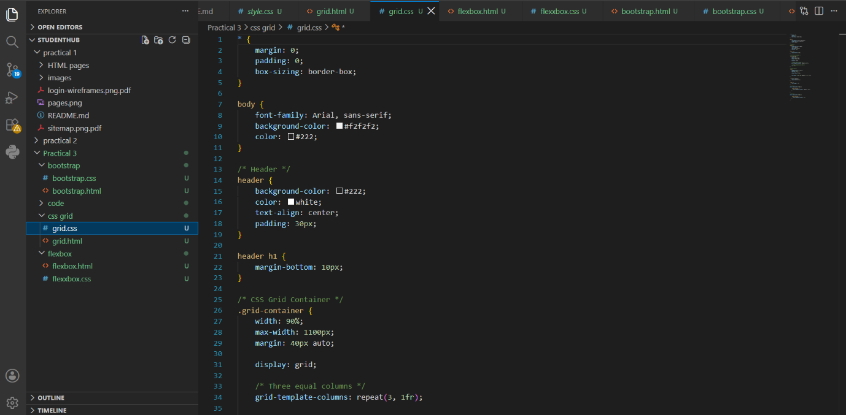

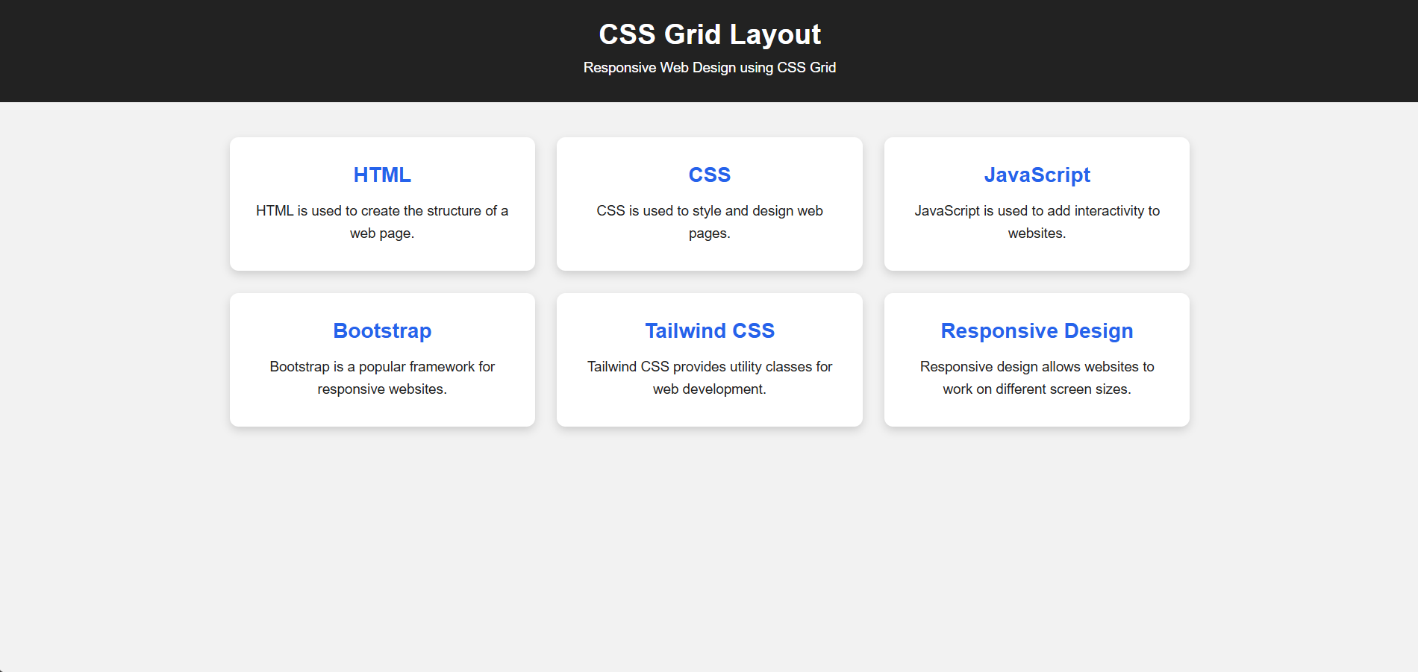

Flexbox Html code and output:
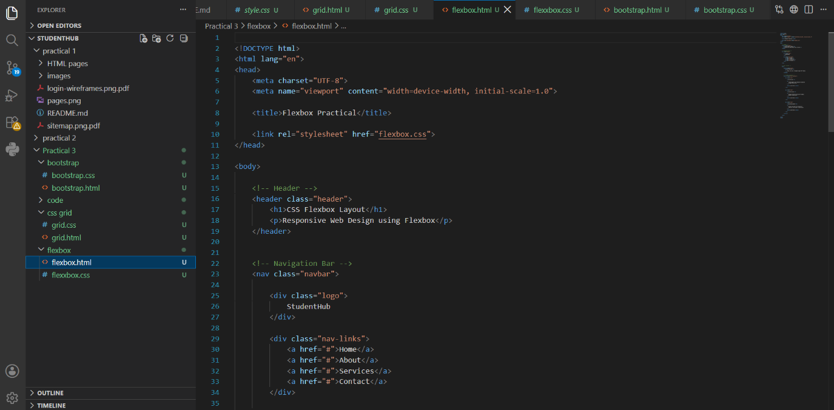
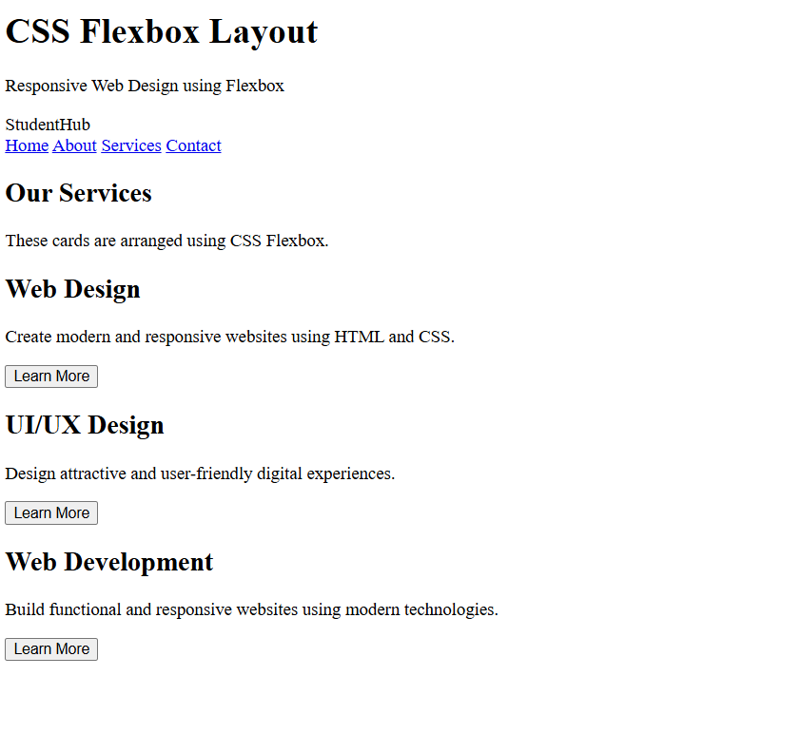

Flexbox CSS code and output:
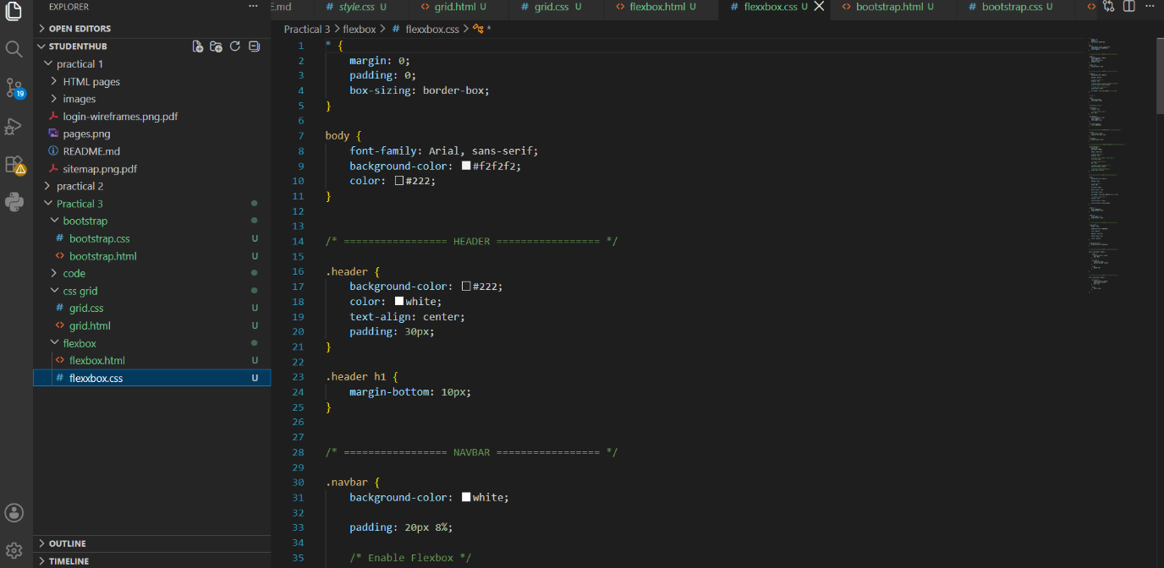

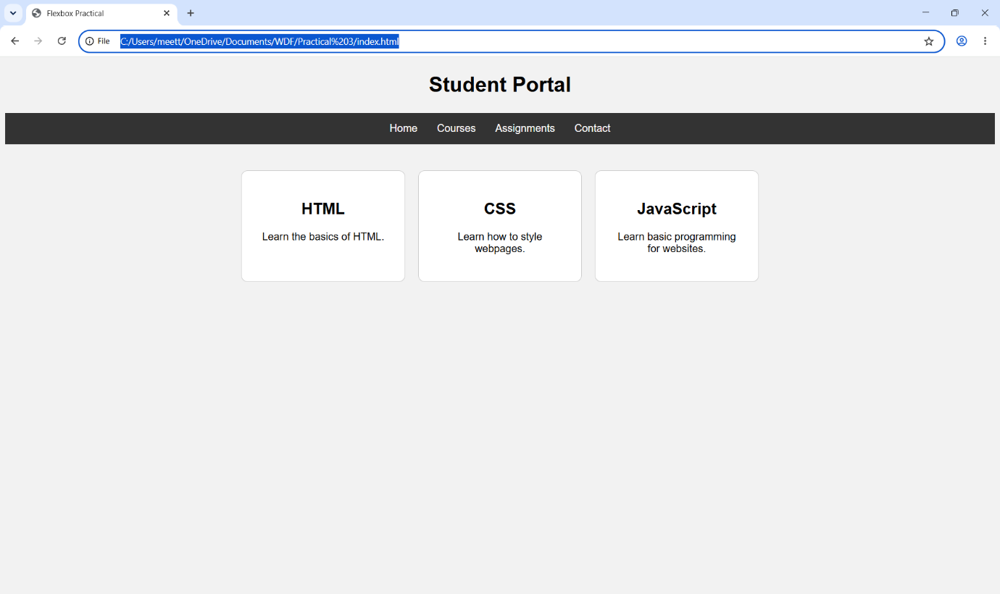
Bootstrap html code and output:
